Table of Contents
Overview 2
Goals and Scope 2
Project Goals 2
Project Scope 3
Included 3
Excluded 3
Organization 3
Organizational Boundaries and Interfaces 3
Resource Owners 3
Receivers 3
Sub-contractors 3
Suppliers 3
Cross Functions 3
Other Projects 4
Project Organization 4
Project Manager 4
Project-internal Functions 4
Project Team 4
Steering Committee 5
Schedule and Budget 5
Work Breakdown Structure 5
Schedule and Milestones 6
Budget 6
Development Process 7
Development Environment 8
Measurements Program 9
Risk Management 10
Sub-contract Management 10
Communication and Reporting 10
Delivery Plan 11
Deliverables and Receivers 11
Quality Assurance 13
Configuration and Change Management 13
Security Aspects 13
Project Closure 13
Abbreviations and Definitions 13
References 13
Revision 13

Overview
Đề tài 5: Quản lý đặt phòng họp cho Khoa CNTT
GVHD: Võ Nhựt Thanh
Khoa CNTT hiện nay có 1 số phòng họp dành cho cả giảng viên và sinh viên tham gia họp, trao đổi, học tập. Quy trình thực hiện xin đăng ký phòng như sau:
- Giảng viên – sinh viên muốn đăng ký phòng: liên hệ với cô Mạnh để đă\]\ ký phòng gồm phòng nào, thời gian nào, mục đích đăng ký phòng họp để làm gì?
- Cô Mạnh sẽ kiểm tra trong danh sách đăng ký, nếu còn trống thì sẽ cho đăng ký, nếu không thì sẽ thông báo là phòng đó không trống.
- Cô Mạnh có thể gợi ý những phòng họp còn trống để cho họ thay đổi phòng và thời gian (nếu cần).
Tuy nhiên, có những khó khăn là khi đăng ký phòng, cô Mạnh không ở văn phòng thì cũng không biết phòng nào còn trống phòng nào đã đăng ký. Do đó, cần một phần mềm hỗ trợ giúp cho việc hiển thị thông tin các phòng đã đăng ký, phòng còn trống để giảng viên – sinh viên muốn đăng ký sẽ thấy được dễ dàng.
Yêu cầu phần mềm:
- Hiển thị danh sách các phòng họp, thay đổi màu sắc cho trạng thái phòng:
  - Phòng trống (Xanh)
  - Phòng đã đăng ký (Vàng)
  - Phòng đang sử dụng (Đỏ)
- Đăng ký phòng
- Thay đổi phòng
- Trả phòng
- Thống kê tình hình sử dụng phòng
This project will provide a solution for Meeting Room Booking System (MRBS) in customers care problem. Customer of project is lecturer’s IT department. This project will provide a new software product to manage MRBS customers, to manage meeting room. Manage sending email notify for borrwer know information of room.
The project will spend about 3 months to complete with cost is about …
Project organizations include:
Software management
Software development team – K15T1 team 1
Mentor Vo Nhut Thanh.

Goals and Scope

Project Goals

Project Goal | Priority | Comment/Description/Reference
Functional Goals: | 2 | For details see the Project Requirements Specification [2]
Borrower management | 4 | See SRS
Room management | 3 | See SRS
Business Goals:
Release date | 4 | 13th August 2012 (case just apply in first phase)
Cost of product | 4
Technological Goals:
Quality Goals:
Accessibility | 3 | Using friendly, easy for maintaining and upgrade.
Reliability | 5 | Management room have effective
Constraints:
Environmental | 5 | Windows 7 or Vista, support SQL management or support SQLite, support netframe work 3.5 and 4.0
The priority is rated as: 1=very low, 2=low, 3=moderate, 4 = high, and 5=very high.

Project Scope
MRBS system to respond requirement of IT department for to raise quality take care of customer service and to get commission of Van Lang University. Specific requirement in SRS

Included
The deliverables of this project and their receivers are listed in detail in the delivery plan in chapter 10.

Excluded

Organization

Organizational Boundaries and Interfaces

Resource Owners
Resource Owners are defined in the Resource Plan in section 5.1.

Receivers
Receivers are defined in the Delivery Plan in section 10.

Sub-contractors
Sub-contractors are defined in the sub-contract management in section 8.

Suppliers

Company: Contact | Deliverable | Comment
Honda head agent ABC | Requirements

Cross Functions

Function | Dept.: Contact | Responsibility/Comment
Product Management
Marketing
Sales
Service
Training
Manufacturing
Quality
Technology
Supply Management

Other Projects

Project | Org.: Project Mgr | Dependency | Comment

Project Organization

Project Manager

Role | Organization: Name
Project Manager | Van Bich Thi Le
Technical Lead & Supporder | Son Dang Huy

Project-internal Functions

Function | Organization: Name | Comment
Tester | Huyen Thach Ding Le, Tin Trung Nguyen | Son Huy Dang is supporter and project manager review
Developer | Son Huy Dang, Tam Minh Do, Huyen Thach Dinh Le, Tin Trung Nguyen | Son Huy Dang is master for coding and project manager review
Recorder | Huyen Thach Dinh Le | Project manager review

Project Team

Organization: Name | Availability | Comment
Van Bich Thi Le | Online
Son Huy Dang | Online
Tam Minh Do | Online
Tin Trung Nguyen | Online
Huyen Thach Dinh Le | Online

Steering Committee
The Steering Committee (SteCo) of the project is responsible for ….
The SteCo consists of the following members:

Organization | Name | Comment
Software management | Van Bich Thi Le | Team Leader
Recorder of team | Tam Minh Do
Technical Leader | Son Huy Dang
Testing Leader | Tin Trung Nguyen

Schedule and Budget

Work Breakdown Structure
The Work Breakdown Structure (WBS) is documented in [4].
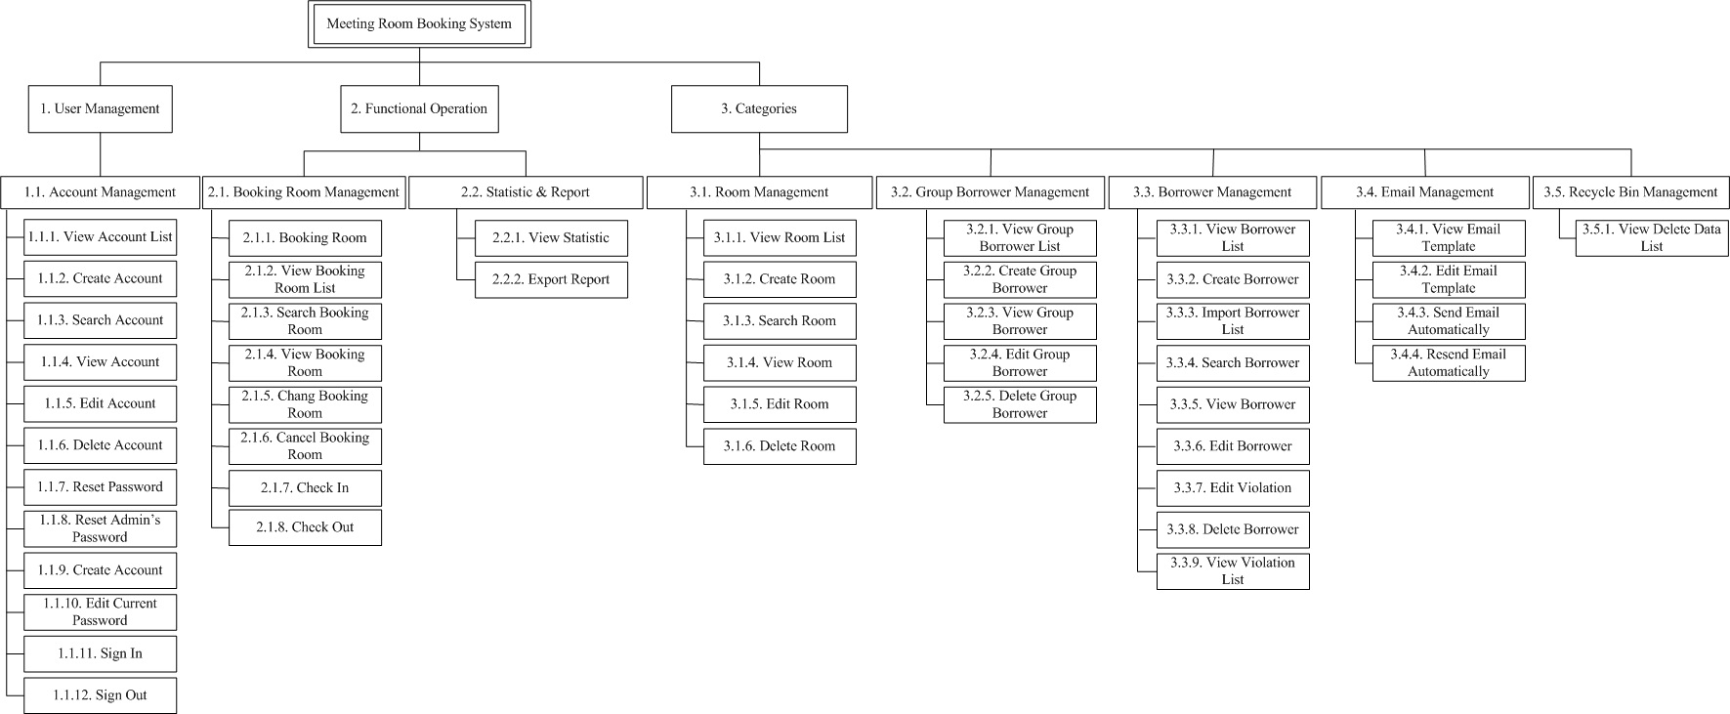

Schedule and Milestones
A detailed Project Schedule is available in [3]. The Project Schedule is monthly updated by the Project Manager. (Read Schedule in exel file)

Budget

Category | Budget for Period
Category | Planning | Develop | Release
Human Resources (internal)
Human Resources (external)
Purchases (COTS)
Equipment
Premises
Tools
Travel costs
Training
Review activities
Other
Total
Total cumulated

Development Process
Waterfall model.
After finish a feature, we release a new prototype. Get customers response and analyze them to find problems and new customers ‘s requirement. After then we develop plan, develop requirement document, develop design document, develop program.
If that prototype meet all customers requirements, we release program and install for users.
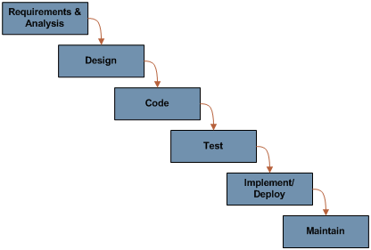

Development Environment

Item | Applied for | Availability by
Methods
Use Case | Requirements capturing
Activities diagram | Requirements capturing
Flow diagram | Design program
Tools
Visio 2010 | Design
Visual Studio 2008 | Programming
SQL express 2005 | Manage database
Google code with Tortoise SVN | Manage data
Languages
UML | Design
C# | Programming

Measurements Program

Content | Goals | What to be measured
Project cycle time | Ensure project complete on time | Size, schedule and budget of software in plan
Project cycle time | Ensure project complete on time | Size, schedule and budget of software in actual
Project quality | Ensure project has a high quality, numbers of error code lines will reduce 10% after each release. Expected to have about 1 error in 100 code lines. | Number lines of code
Project quality |  | Number of errors

Data should be measured
Entity | Attribute | Metrics
Software design | Defect discovered in design reviews. | Number of found defects in a hour
Software design | Defect discovered in design reviews. | Time of a member spend to find a defect.
Software design | Defect discovered in design reviews. | Number of defects in each review task
Schedule | Time to complete a task | Number of hours used to do a task.
Schedule | Cost to complete a task | Money for a task
Schedule | Human resource used in a task | Average people to do a task
SDS | Number of pages | Lines in a page.
SDS | Number of pages | Lines of code (design) a page.
Software code | Number of code lines | Number errors in 1000 code lines in an release
Software code | Number of operations | Number errors operation in 100 operation in an release
Software team | Team size, team skills

Risk Management

Sub-contract Management

Sub-contractor |  | Sub-contracted Work | Ref. to sub-contract
Company | Contact | Sub-contracted Work | Ref. to sub-contract

Communication and Reporting

Type of Communication | Method / Tool | Frequency/Schedule | Information | Participants / Responsible
Internal Communication:
Project Meetings | Peer to peer | Weekly and on event | Project status, problems, risks, changed requirements | Project Manager  Project Team
Sharing of project data | Shared Project Server | When available | All project documentation and reports | Project Manager(s)  Project Team Members
Milestone Meetings | Peer to peer | Before milestones | Project status (progress) | Project Manager  Sub-project Manager
Final Project Meeting | Peer to peer | M6 | Wrap-up  Experiences | Project Manager  Project Team
External Communication and Reporting:
Project Report | Excel sheet | Monthly | Project status  - progress  - forecast  - risks | Project Manager  Sub-Project Managers
Customer’s meeting | meeting | Monthly or after a pharse |  | Project Manager, Customer

Delivery Plan

Deliverables and Receivers

Ident. | Deliverable | Planned Date | Receiver
D1 | 1. Team process  2. Team document template. | 30/09/2011 | 1. Project manager  2. Supporter (Technical lead) & all team member  3. Recorder
D2 | 1. Master plan document | 19/10/2011 | - Project manager
D3 | 1. Schedule document | 19/10/2011 | - Project manager
D4 | 1. SRS document | 23/10/2011 | 1. Project manager  2. Recorder  3. Supporter (Technical lead)
D5 | 1. Database design document | 30/10/2011 | 1. Supporter (Technical lead)  2. Recorder  3. Project manager
D6 | 1. Feature 2 design document | 20/11/2011 | 1. Supporter (Technical lead)  2. Developer  3. Project manager & Recorder
D7 | 1. Feature 4 design document | 26/11/2011 | 1. Supporter (Technical lead)  2. Developer  3. Project manager & Recorder
D8 | 1. Database file | 30/11/2011 | 1. Supporter (Technical lead)  2. Developer  3. Project manager & Recorder
D9 | 1. Source code of feature 2  2. Bug report | 05/12/2011 | 1. Supporter (Technical lead)  2. Developer  3. Project manager & Recorder
D10 | 1. Source code of feature 4  2. Bug report | 10/12/2011 | 1. Supporter (Technical lead)  2. Developer  3. Project manager & Recorder
D11 | 1. System test report | 15/12/2011 | 1. Tester  2. Supporter (Technical lead) & Developer  3. Project manager & Recorder
D12 | 1. Running status report.  2. Result document | 17/12/2011 | 1. Supporter (Technical lead) & Developer  2. Tester, Project manager & Recorder
D13 | 1. Customer response document. | 20/12/2011 | 1. Supporter (Technical lead) & Tester
D14 | 1. Customer's satisfaction document. | 23/12/2011 | 1. Project manager  2. Supporter (Technical lead)  3. Recorder & all team member
D15 | 1. User manual | 28/12/2011 | 1. User manual
Etc.

Quality Assurance

Configuration and Change Management

Security Aspects

Project Closure
Reading the documents :
- “02. K15T01-Team#2-Team Assignment#6-Project Closure.doc”
- “03. K15T01-Team#2-Team Assignment#6-Project Charter.doc”
- “04. K15T01-Team#2-Team Assignment#6-Project Closure Checklist.doc”
- “05. K15T01-Team#2-Team Assignment#6-Project Closure Report_Template.doc”
- “06. K15T01-Team#2-Team Assignment#6-Project Lesson Learned.doc”

Abbreviations and Definitions
CCB Change Control Board
CI Configuration Item
CM Configuration Management
COTS Commercial Off The Shelf
CR Change Request
CRM Change Request Management
ID Identification, Identifier
IP Intellectual Property
QA Quality Assurance
SteCo Steering Committee
V&V Verification and Validation

References
- <Doc. 1.> Project Proposal for SMS project
- <Doc. 2.> Project Requirements Specification for SMS project
- <Doc. 3.> Project Schedule for SMS project
- <Doc. 5.> Work Breakdown Structure for SMS project

Revision
Rev. ind. | Page (P)  Chapt. (C) | Description | Date  Dept./Init.
V1 |  | original version | 25th Oct 2011

